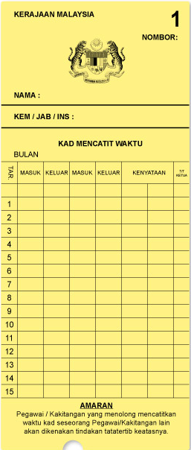

12

IT DEPARTMENT

NIK GOOGLE